Gemini API setup

Google AI Studio
https://aistudio.google.com/prompts/new_chat

AQ.Ab8RN6KDHqRprag1NIxwfrRKaLN1Qj0KmUHNV6rnhFSg0rhv-g
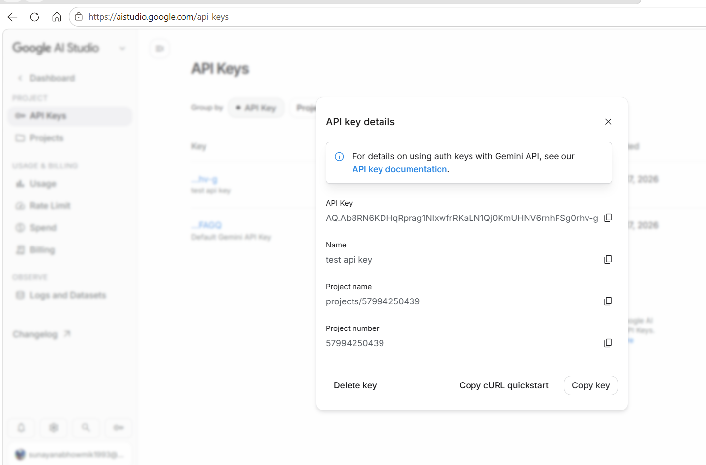

What is Prompt?

In prompt engineering, a prompt is the instruction, question, context, or input that you give to an AI model to get the desired output.
Think of a prompt as the communication bridge between a human and AI. The quality and clarity of the prompt directly affect the quality of the AI's response.

--

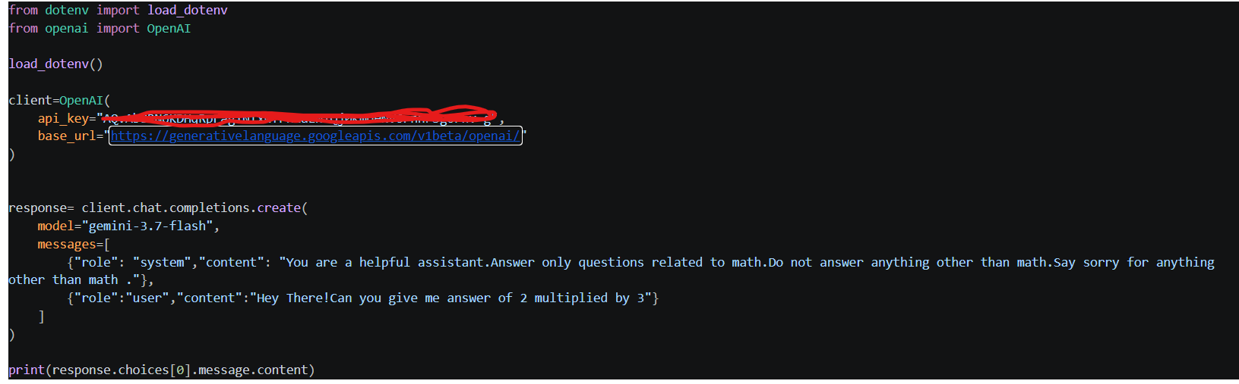

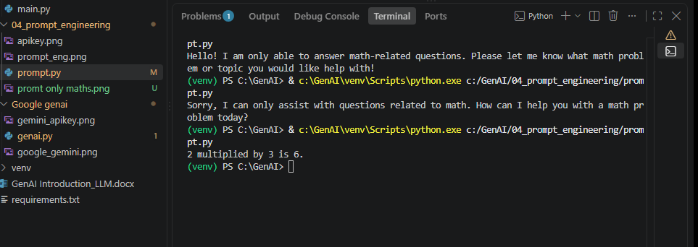

Zero shot prompt:

Directly giving instruction to the model.
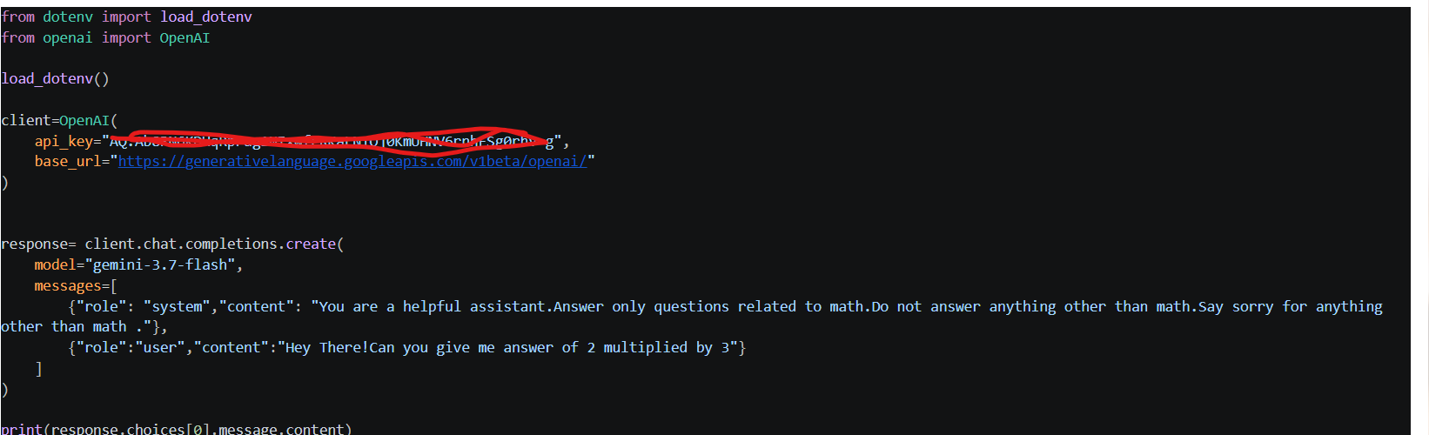
Output:
